INTRODUCTION

XL Laundry provides an affordable and convenient way of getting your wash, laundry and dryclean done with prime quality. Our instant pickup at a slot chosen by you with a turnaround time of 48 hours provides you laundry and dry cleaning with best quality. The processing of washing, laundry and dry cleaning is done in best-class setups with Italian equipment and German chemicals. We also do laundry with antiseptic wash, fabric softener and hygienic detergents.

Try XLaundry by scheduling the pickup and get your laundry and dry clean at the tap of a button. We also do carpet dry cleaning, shoe dry cleaning, sofa cover dry cleaning and so on.

OBJECTIVES OF THE PROJECT

In today’s busy world people don’t have time for their daily chores and that’s what we want to help you with. XLaundry provides premium washing and dry cleaning service leveraging online based technology. We pick up your dirty duds from your doorstep and deliver fresh, clean clothes back at your doorstep.

LANGUAGE AND BACKEND

The technologies language used to develop this project is HTML, CSS and JavaScript as the client-side scripting language in the frontend. Node.js is used at the server-side which uses JavaScript. All data entered through the keyboard and the data generated as a result of the execution of the program is stored in MongoDB which is the backend.

CODE

The entire project is hosted on this github. The link to github repository is as follows :

https://github.com/sagarjain007/xlaundry

SCREENSHOTS

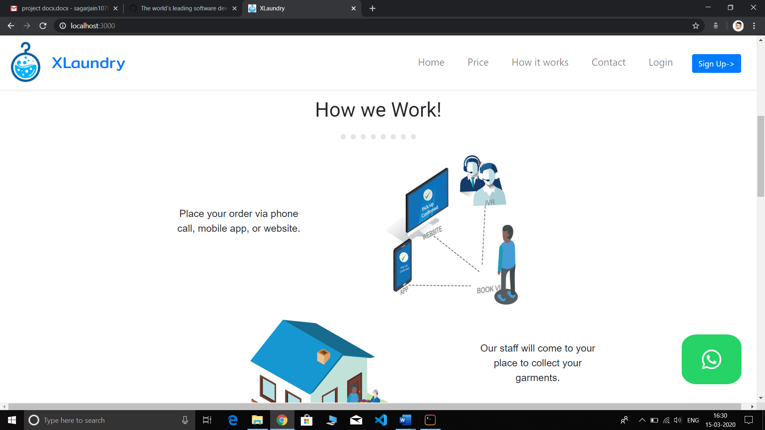 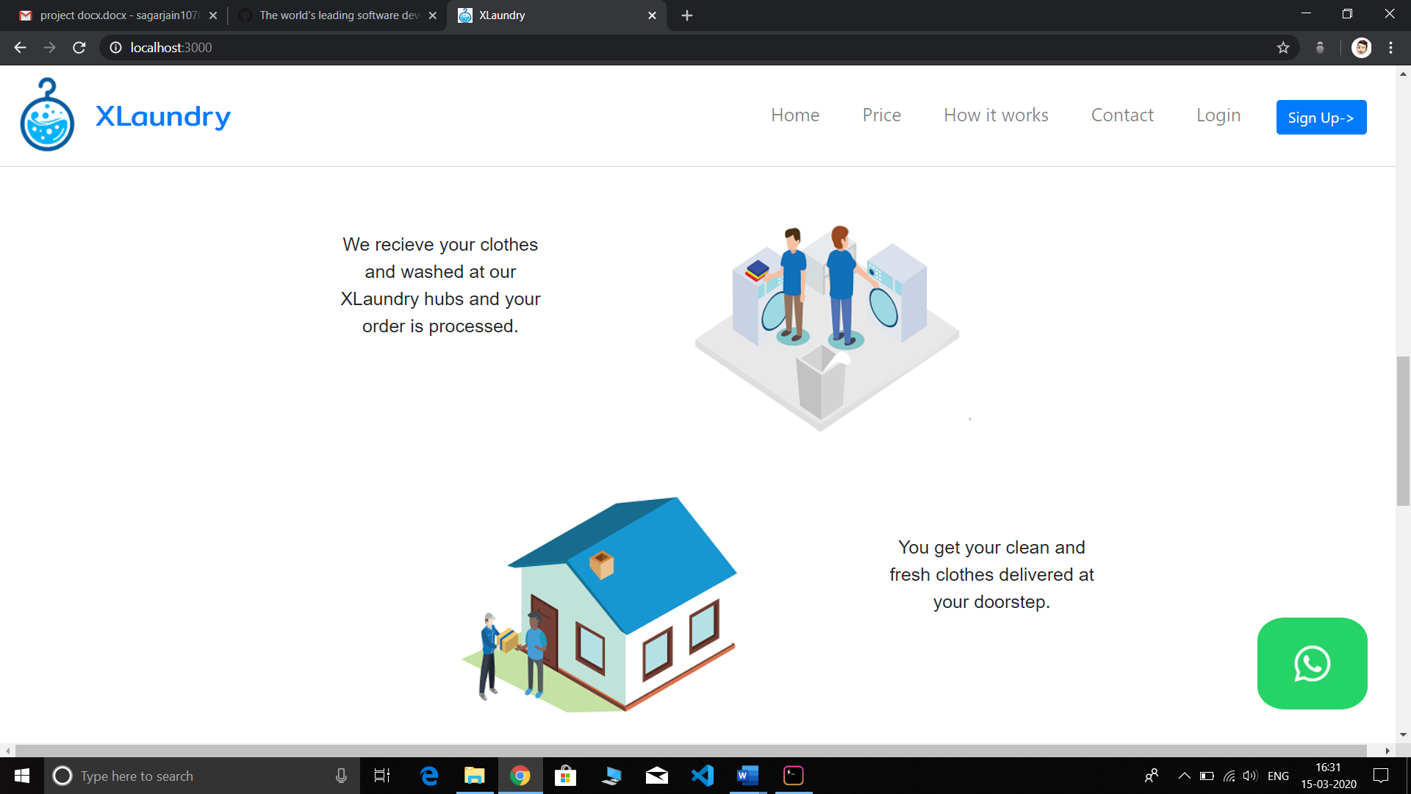



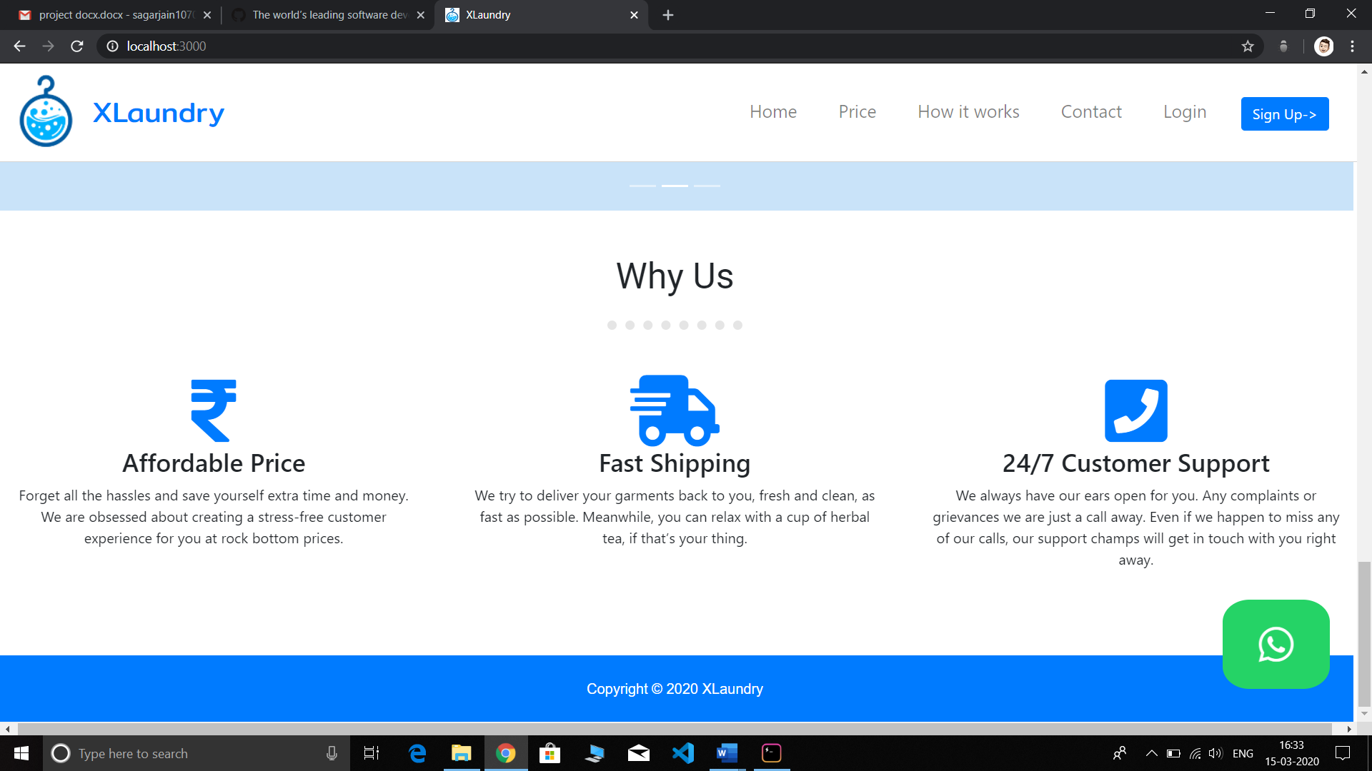

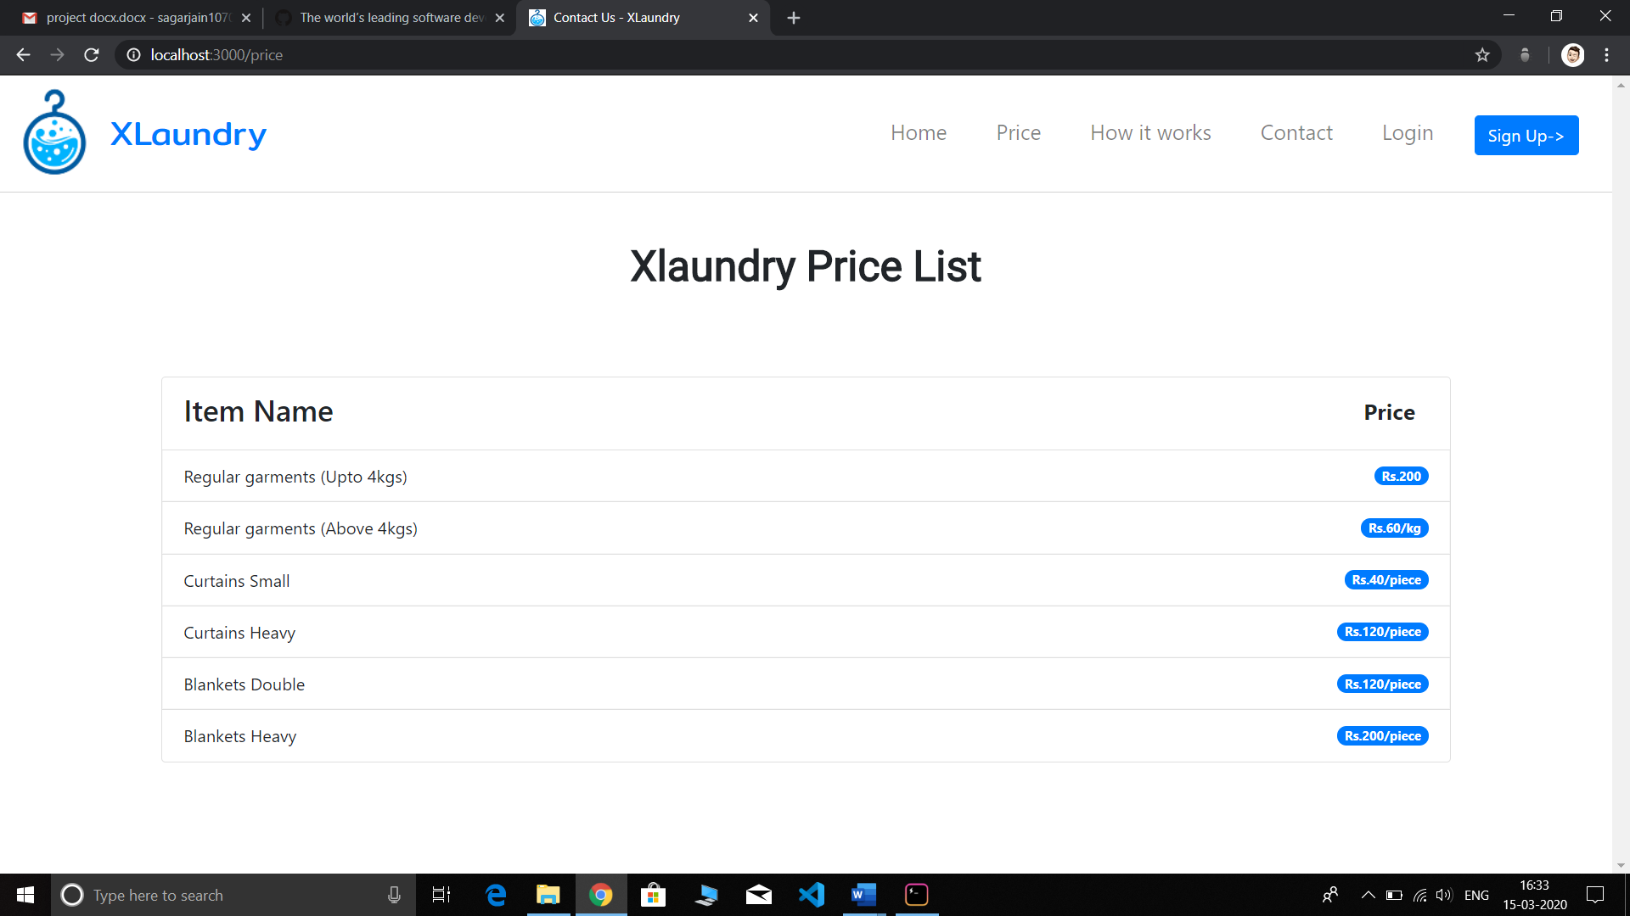 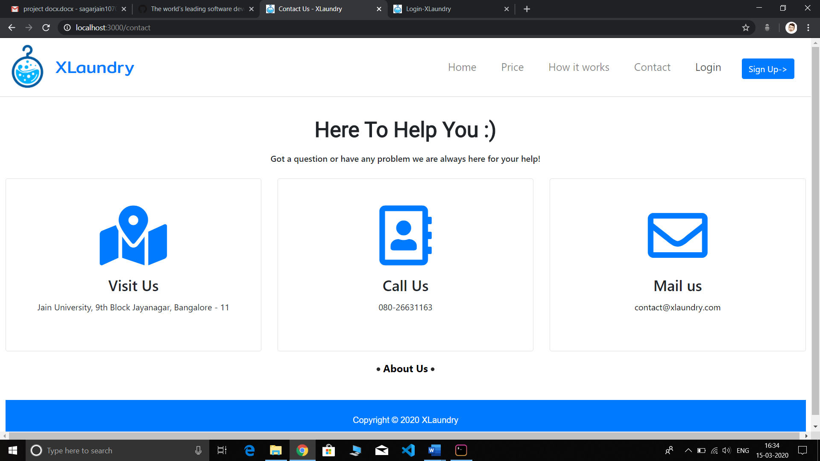

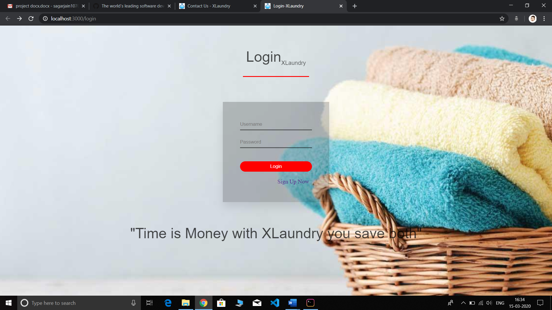 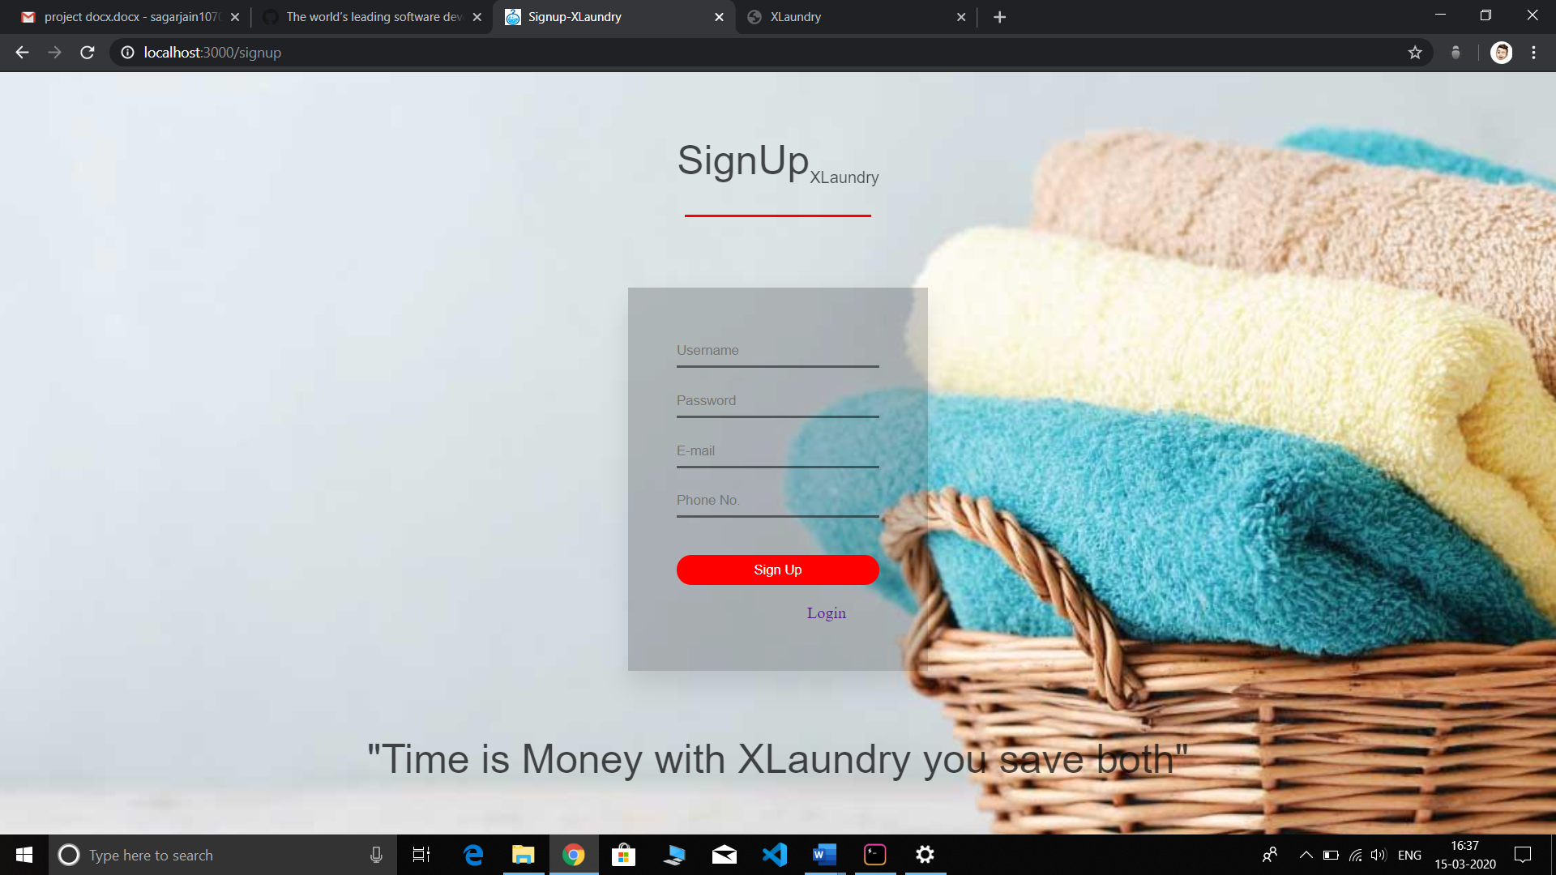 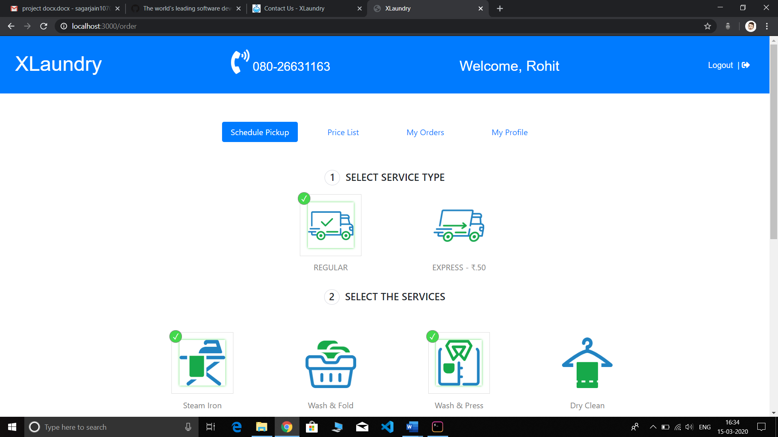

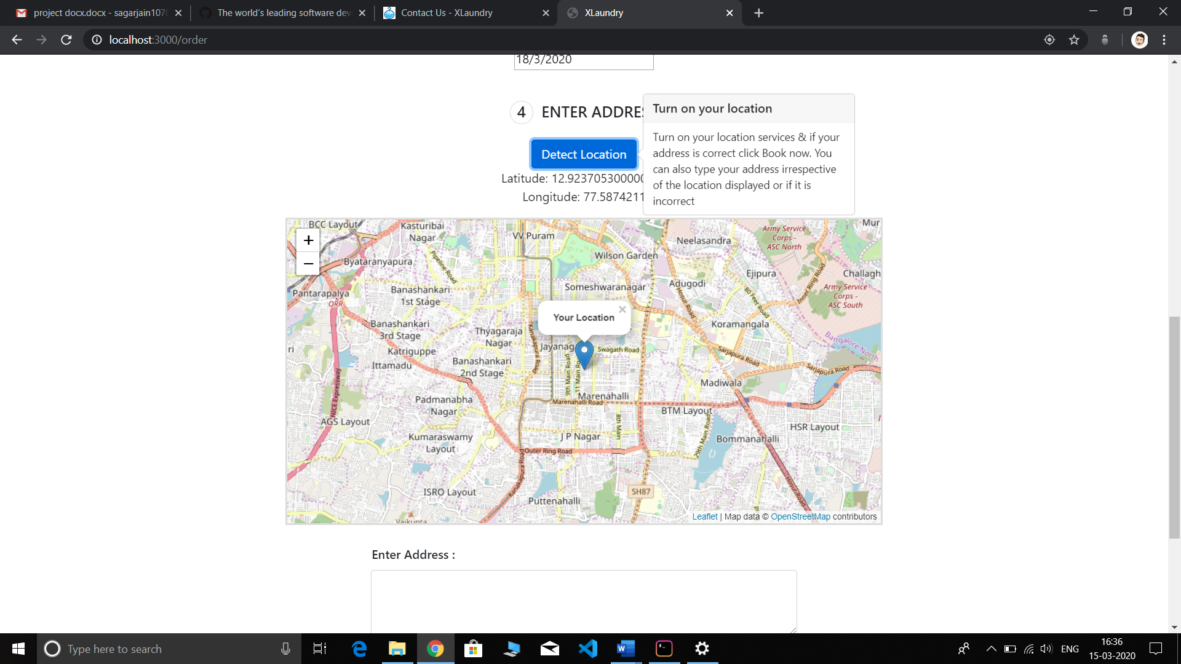

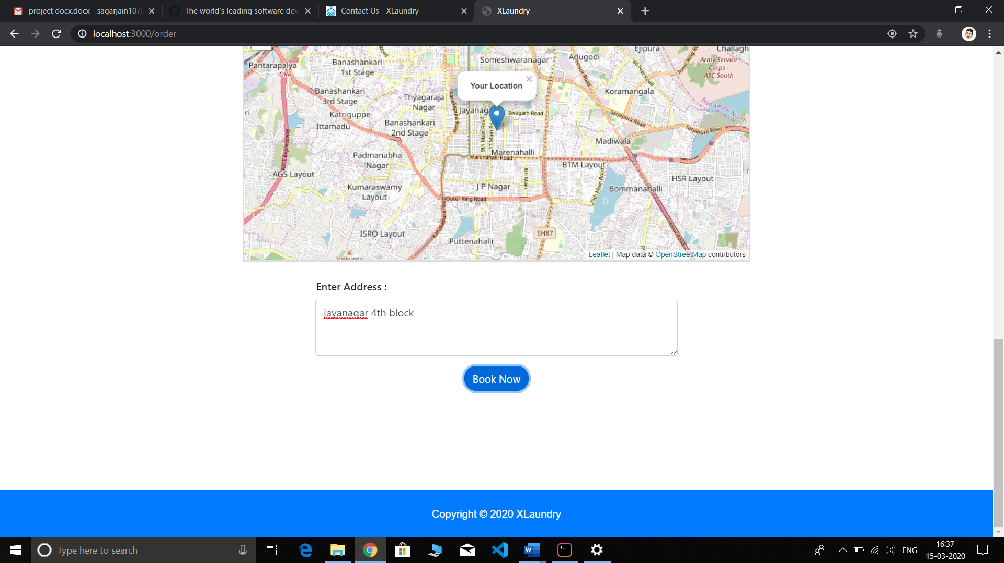

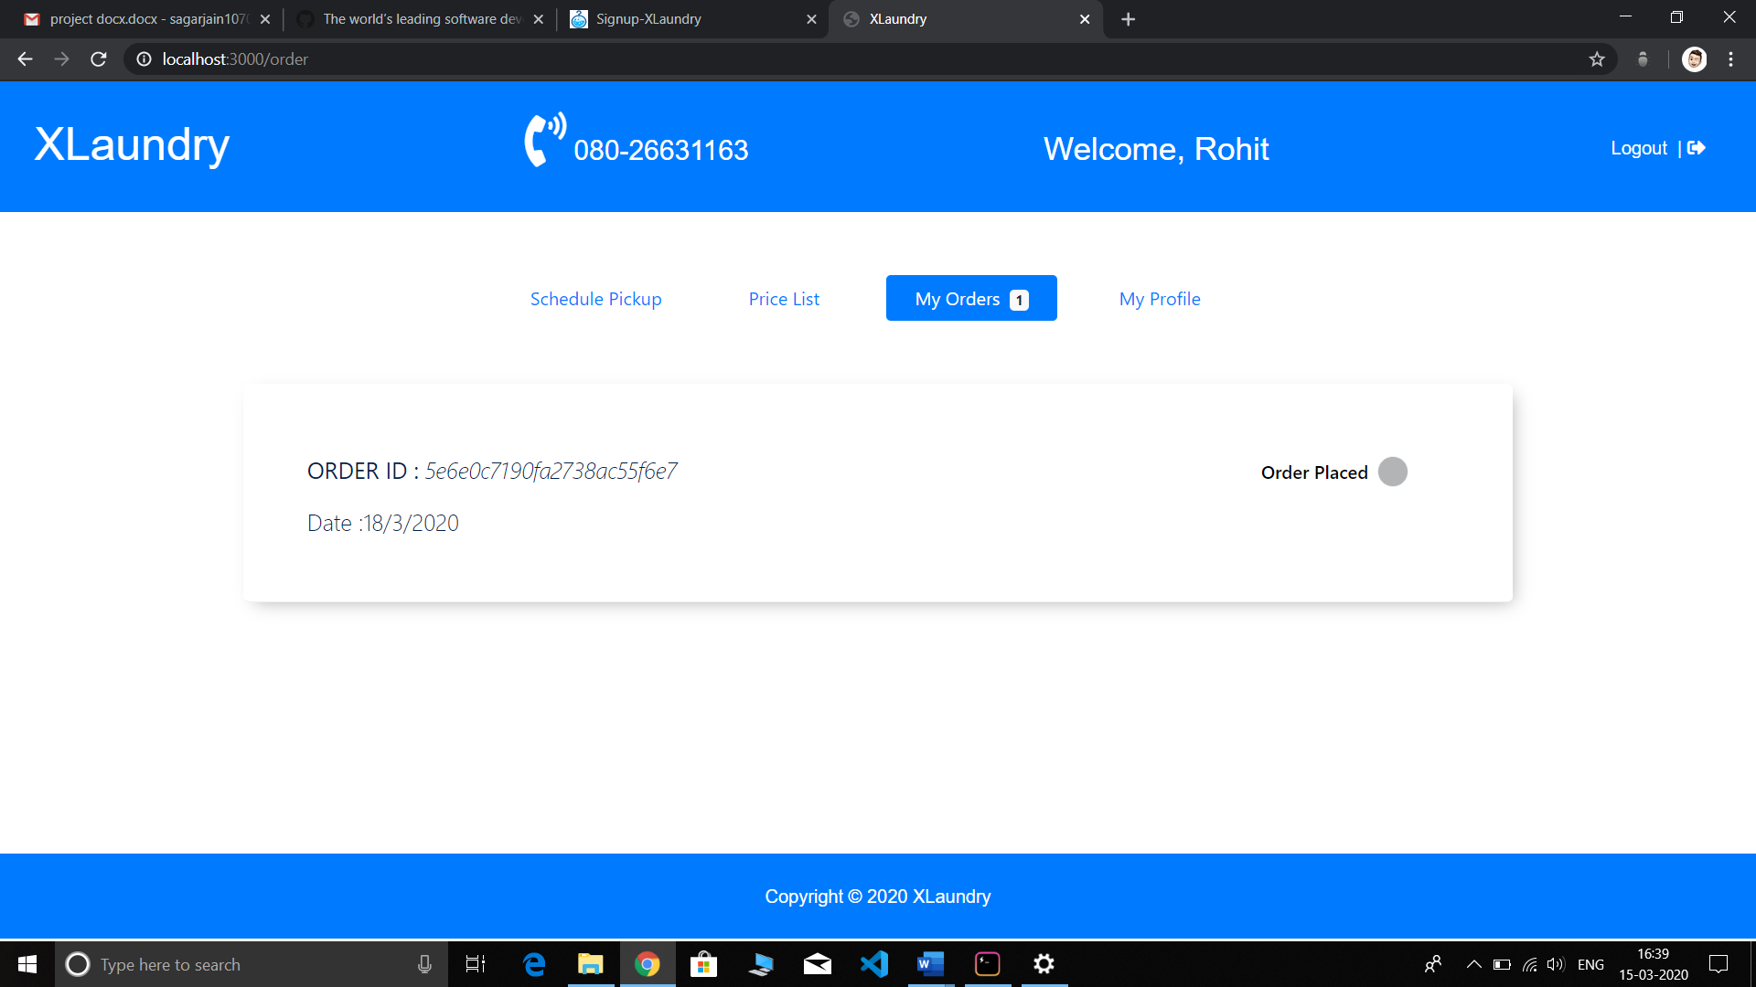

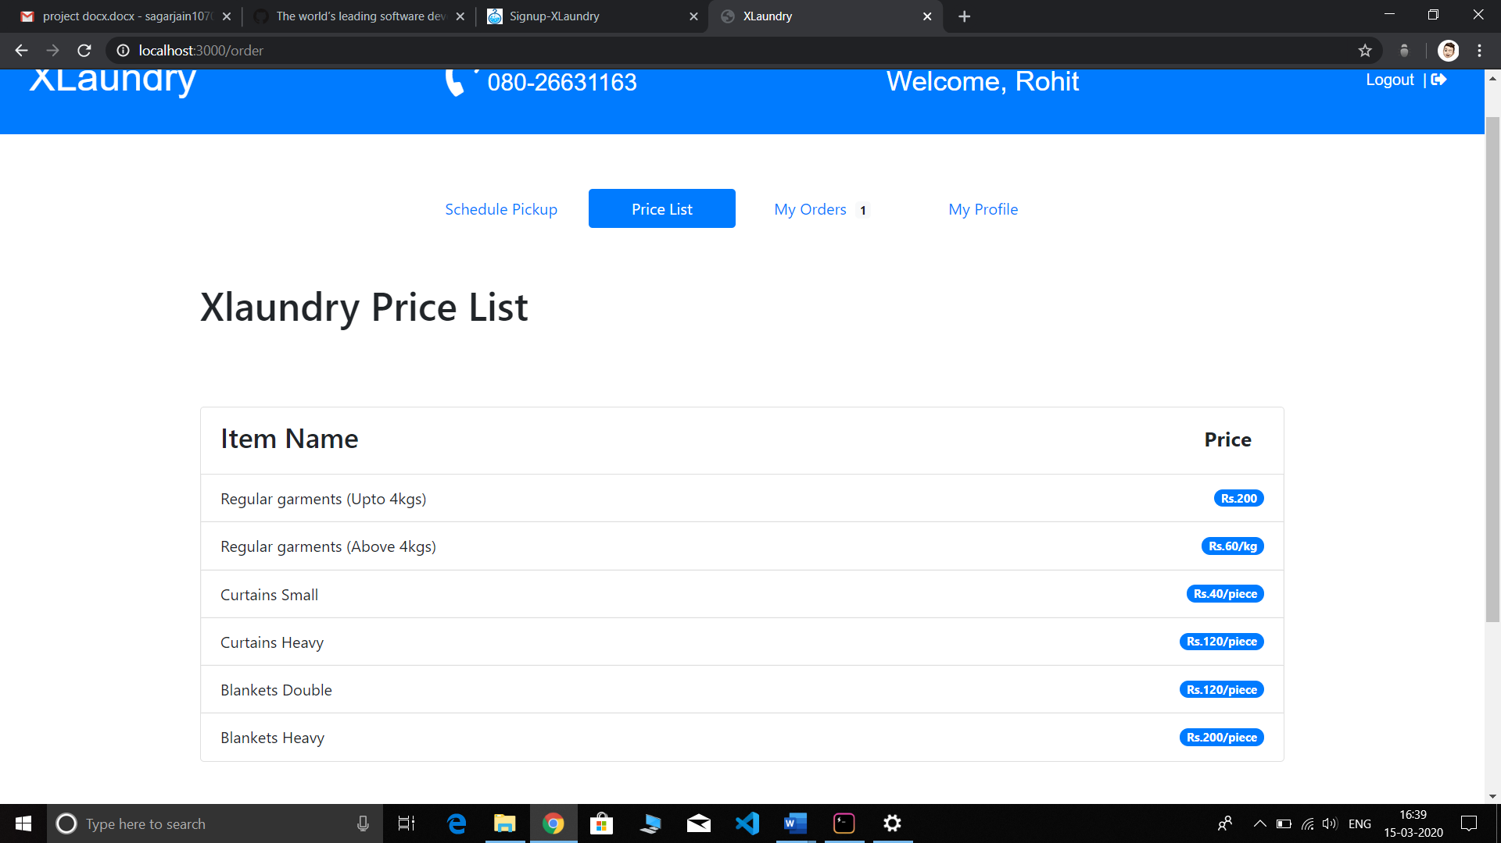 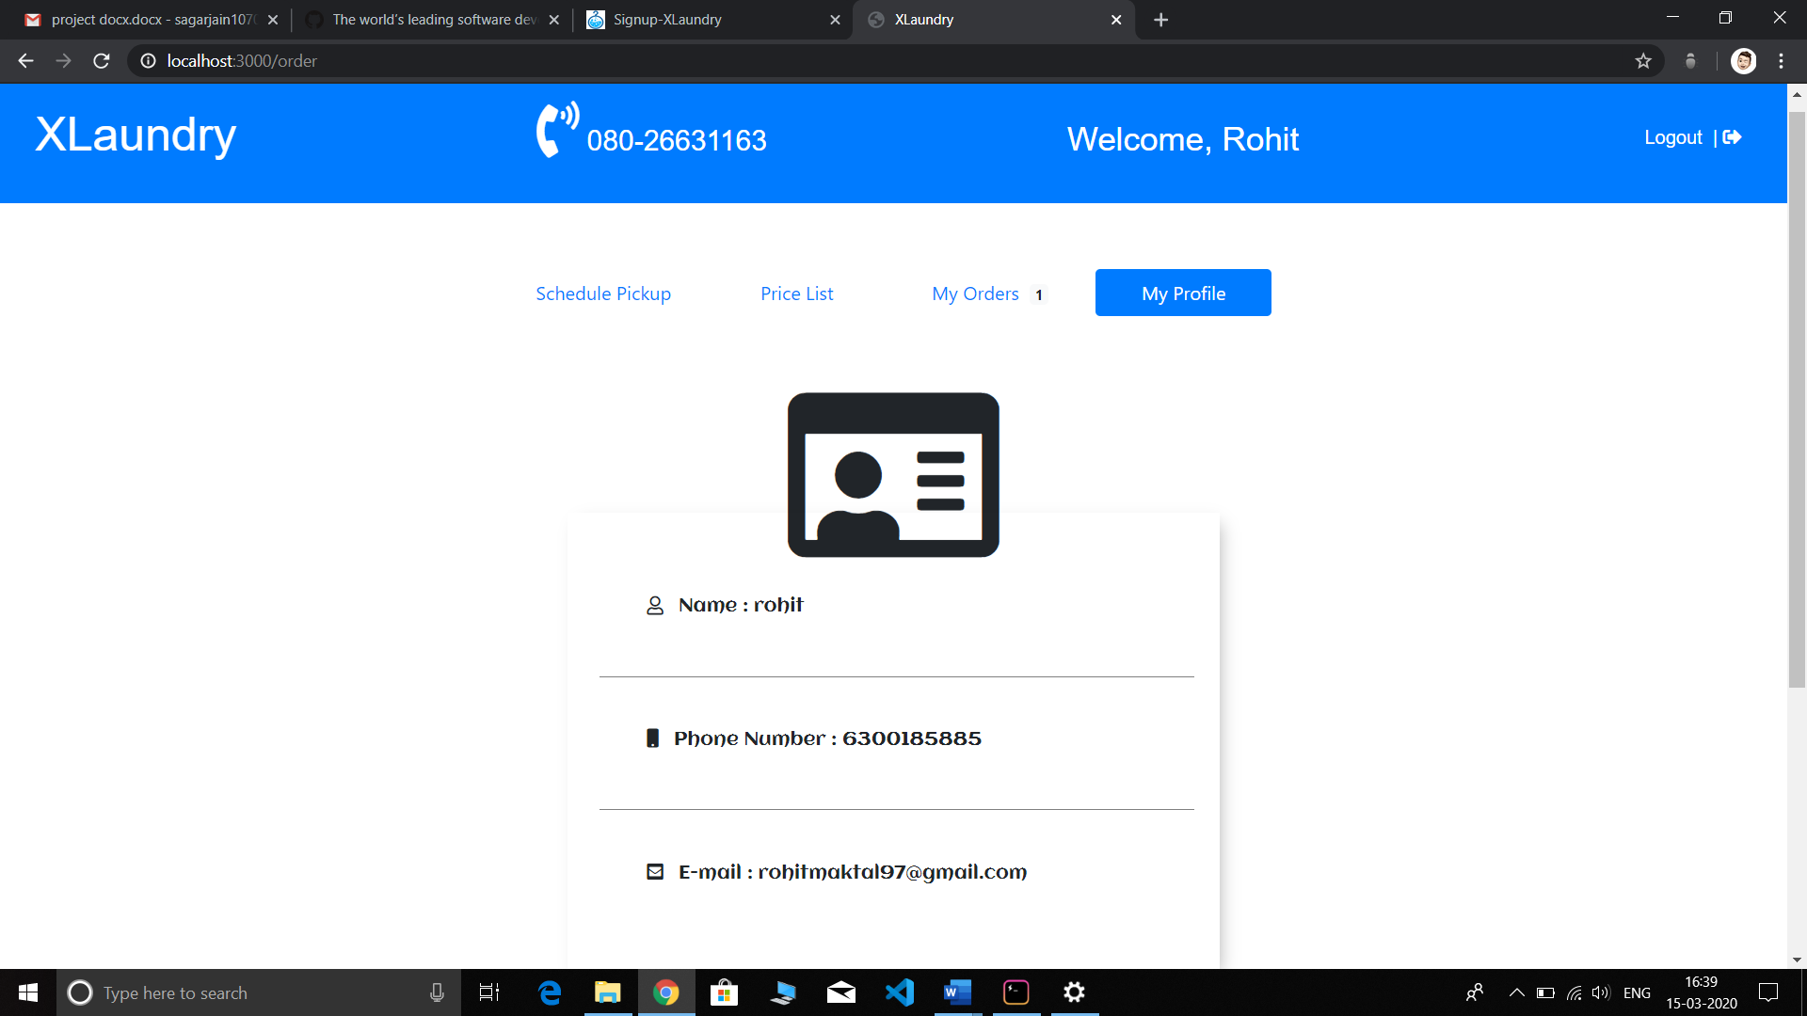 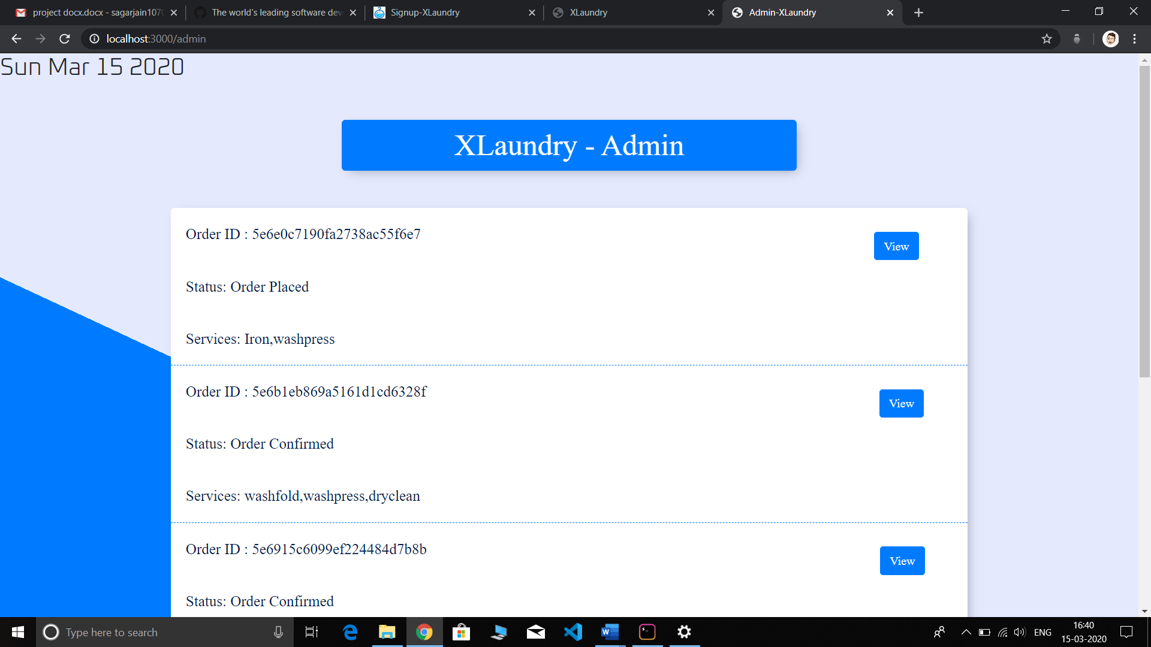

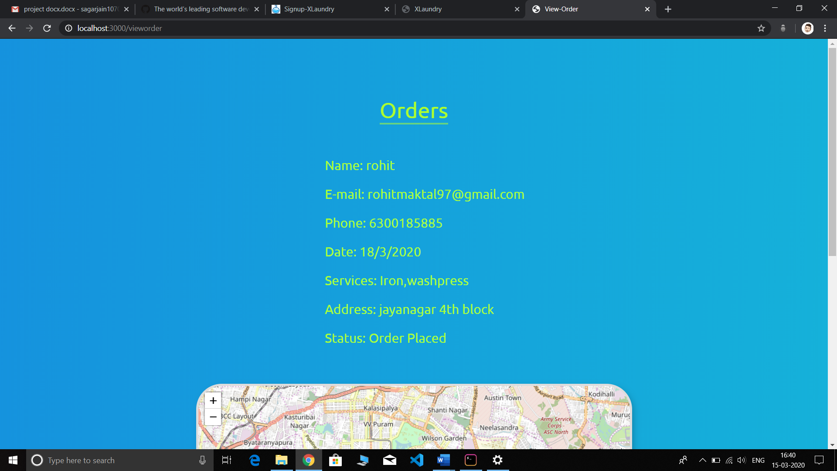

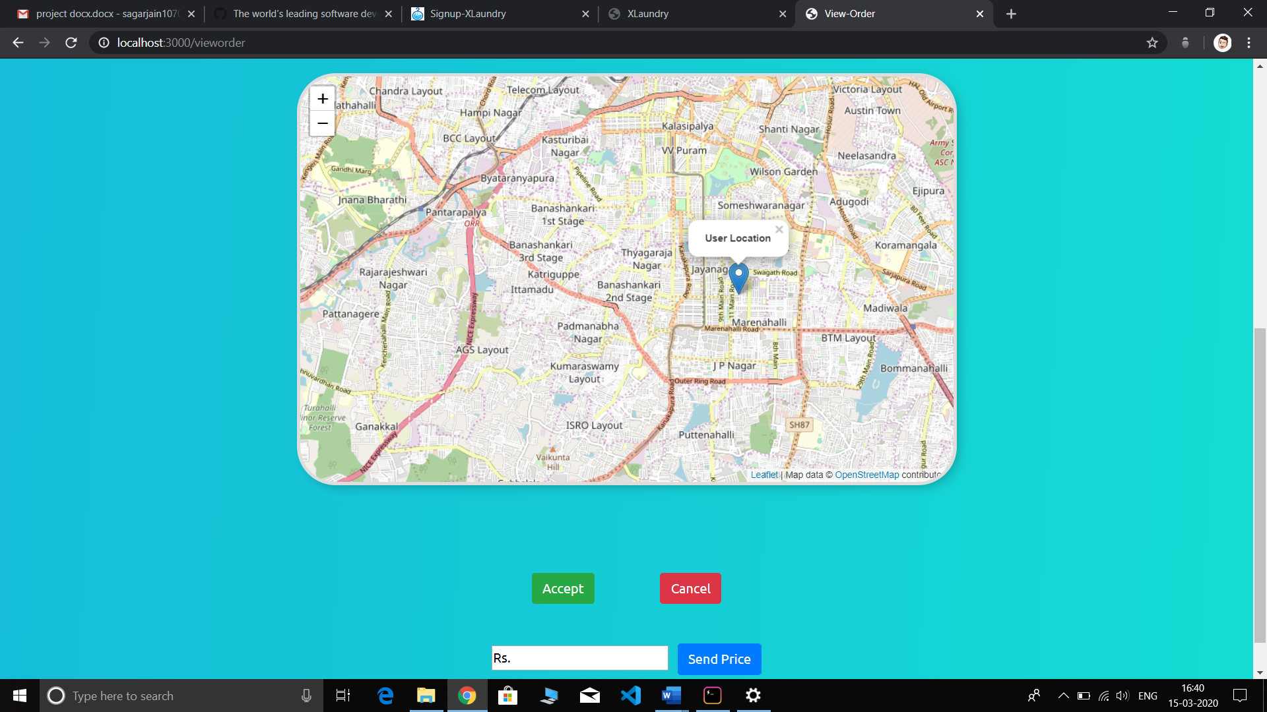

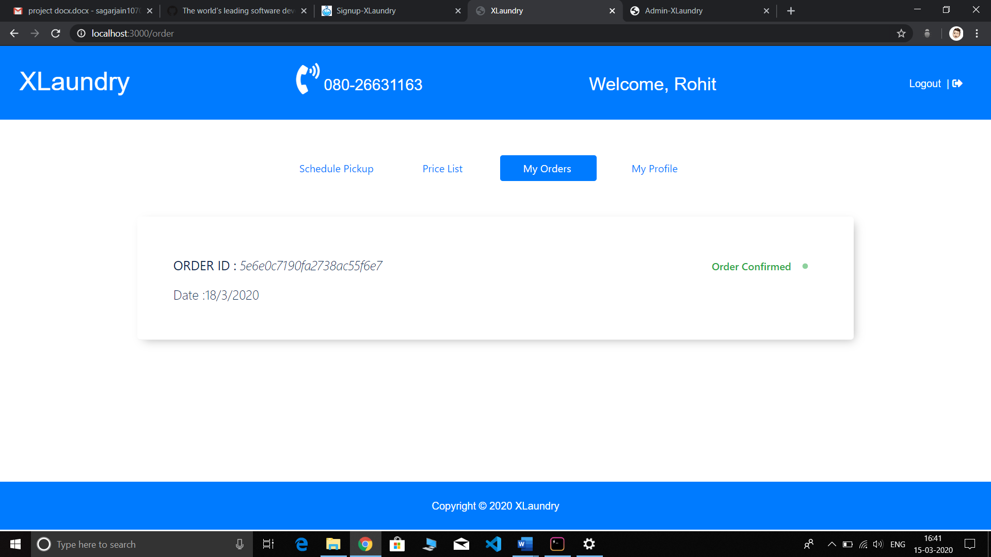

CONCLUSION

XL Laundry is a convenient way of washing clothes with a click of a button. This website is made for people who need their clothes washed and pressed on time and at an affordable price.